EXERCISE UNIT 10

- Choose the word or phrase (A,B,C,D) that best fit the blank space in each sentence
- I am very _____________________. Is there anything to drink?
- dirty B. hungry C. thirsty D. full
- I’m tired. I’d like to______________ .
A. have noodles B. play games C. watch TV D. sit down
- What ____________ you like? – I’d like some water.
A. are B. do C. would D. be
- Cabbages are my favorite_______________.
A. a fruit B. vegetables C. food D. drink
- My mother wants a ____________________of toothpaste.
A. bar B. box C. tube D. bowl
- There is ____________ bread and rice on the table.
A. a B. some C. any D. many
- _____________________? - He feels tired.
A. How he feels B. How does he feel C. How is he feel D. How would he feel
- When I’m hot, I’d like some ____________________.
A. iced tea B. ice tea C. icing tea D. ices tea
- Lemons, oranges, bananas, apples are _____________________.
A. food B. meat C. drink D. fruit
- Do you like peas ________________ beans?
- or B. and C. with D. for
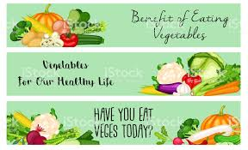
- The picture says: ________________.
A. vegetables are good for your health
B. Children don’t eat vegetables
C. vegetables are beautiful
D. Apples, bananas… are vegetables

- The picture asks you to: __________________.
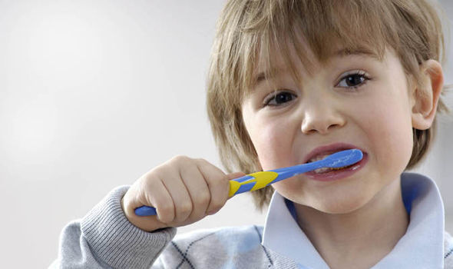
A. Wash your face
B. Brush your teeth
C. Eat breakfast
D. Get dressed

II. Use the correct form of the verb or word given in each sentences
- They are ( eat) _______________ dinner at the moment.
- Are you ( tire ) ______________________, Mai?
- Can I help you? – A bottle of (cook) _______________ oil, please.
- What would you like?- I’d like some (ice) _______________ tea.
III. Rearrange the words or phrases in a correct order to make complete sentences
- you like / ,Hoa? / Would / cold drink / some //
→___________________________________________________________________________
- is / food. / Beef / my favorite //
→___________________________________________________________________________
- iced coffee / There / any / to drink. / isn’t // →___________________________________________________________________________

- breakfast. / some bread / wants / Lan / and milk / for //
→___________________________________________________________________________

IV. Choose the word (A, B, C or D) that best fits the blank space in the following passage
Ba is a student in grade six. His favorite (21)____________ is fish. He likes chicken and meat, too. He often (22)______________ lemonade in the afternoon. He has bread, milk (23) _____________ breakfast. He (24) _____________ fish, meat and rice for lunch. He also likes vegetables.
- A. drink B. food C. fruit D. vegetable
- A. eats B. plays C. drinks D. does
- A. for B. at C. in D. on
- A. watches B. does C. plays D. has

V. Read the following passage then decide if the statements are TRUE or FALSE
It’s half past eleven now and Lan is very hungry. She’d like some things for lunch. She eats rice, fish and vegetables. She likes fish best. She often drinks orange juice, apple juice or water after lunch. She also likes some fruit: bananas, oranges and apples. She doesn’t like tea or coffee. She likes milk.
- Lan has lunch at 11.30.
- Lan’s favorite food is fish.
- She often drinks lemon juice after meals.
- She also likes bananas, oranges and lemons.
Read the passage again and choose the best answer (A, B, C or D)
- The passage is about __________________.
A. Lan’s breakfast B. Lan’s lunch C. Lan’s dinner
- The word “eats” in the first line has the same meaning as ___________________.
A. has B. makes C. does
VI. Rewrite each of the following sentences so that meaning stay the same
- Linh wants some coffee with ice.
→ Linh wants _________________________________________________________________
- Ba likes chicken best.
→ Ba’s favorite ________________________________________________________________
VII. Make questions from the underlined words or phrases
- My favorite food is chicken.
→____________________________________________________________________________
34. They are tired and hot.
→____________________________________________________________________________
35. No. There aren’t any vegetables for dinner.
→____________________________________________________________________________

